The Unchanging God and the Need for Change
The Need for Change – Part 1

What good changes have you seen in our church family over the past year, 5 years or 10 years?

“Your [church] is perfectly designed to yield the result you are getting.”
(Dallas Willard, The Divine Conspiracy)
Legacy Churches: Life-Cycle

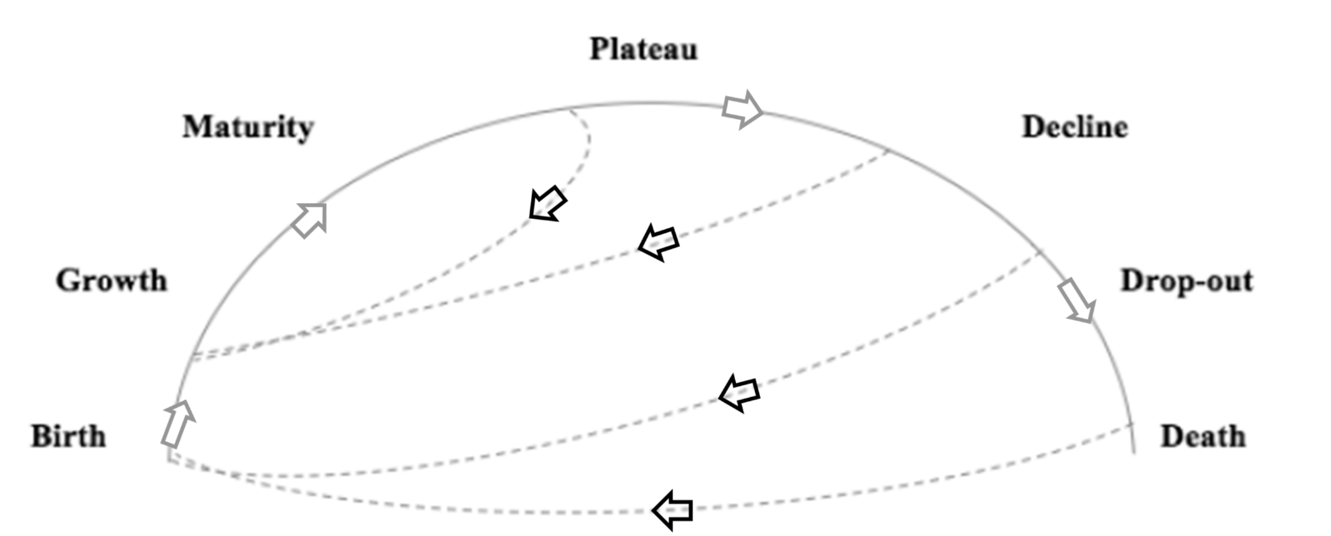

Where do you think we are at in this life-cycle?

Jesus said, ‘Whoever wants to be my disciple must deny themselves and take up their cross and follow me. For…whoever loses [lives] their life for me and for the gospel will save it.’
(Mark 8:34-35)

Where do you feel the challenge or invitation of God in these core verses from this morning? Where is the challenge or invitation for us as a congregation? To die? To follow? Or to live? Or a mix?

The Unchanging God and the Need for Change
The Need for Change – Part 1

What good changes have you seen in our church family over the past year, 5 years or 10 years?

“Your [church] is perfectly designed to yield the result you are getting.”
(Dallas Willard, The Divine Conspiracy)
Legacy Churches: Life-Cycle

Where do you think we are at in this life-cycle?

Jesus said, ‘Whoever wants to be my disciple must deny themselves and take up their cross and follow me. For…whoever loses [lives] their life for me and for the gospel will save it.’
(Mark 8:34-35)

Where do you feel the challenge or invitation of God in these core verses from this morning? Where is the challenge or invitation for us as a congregation? To die? To follow? Or to live? Or a mix?

