The Unchanging God and the Need for Change
The Need for Change – Part 3

Change Principles from Weeks 1 and 2:
- Die (to self) or die out – life comes as we take up our cross
- Fudge or follow the call of Jesus – halfway measures won’t work
- Live for self, or for Jesus – whose agenda are we pursuing?
- Ambassadors not attendees – mission has to be fundamental
- Children not champions – we will feel vulnerable
- Prayerfully on mission – are we fire without heat?

“Your [church] is perfectly designed to yield the result you are getting.”
(Dallas Willard, The Divine Conspiracy)
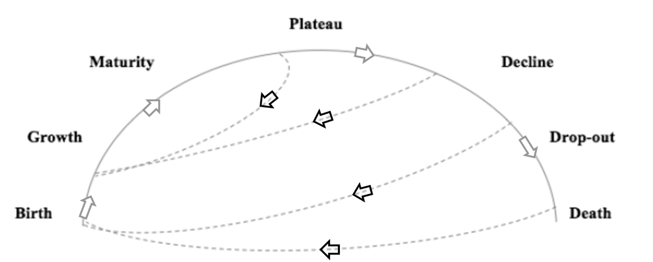
Legacy Churches: Life-Cycle

Jesus said, ‘I am the true vine, and my Father is the gardener…every branch that does bear fruit he prunes so that it will be even more fruitful.’ (John 15:1-2)

Jesus also said, ‘I am the vine; you are the branches. If you remain in me and I in you, you will bear much fruit; apart from me you can do nothing.’ (John 15:5)

And, Jesus finally said, ‘You did not choose me, but I chose you and appointed you so that you might go and bear fruit — fruit that will last — and so that whatever you ask in my name the Father will give you.’ (John 15:16)

Where do you feel the challenge or invitation of God in these core verses from this morning? Where is the challenge or invitation for us as a congregation?
The Unchanging God and the Need for Change
The Need for Change – Part 3

Change Principles from Weeks 1 and 2:
- Die (to self) or die out – life comes as we take up our cross
- Fudge or follow the call of Jesus – halfway measures won’t work
- Live for self, or for Jesus – whose agenda are we pursuing?
- Ambassadors not attendees – mission has to be fundamental
- Children not champions – we will feel vulnerable
- Prayerfully on mission – are we fire without heat?

“Your [church] is perfectly designed to yield the result you are getting.”
(Dallas Willard, The Divine Conspiracy)
Legacy Churches: Life-Cycle

Jesus said, ‘I am the true vine, and my Father is the gardener…every branch that does bear fruit he prunes so that it will be even more fruitful.’ (John 15:1-2)

Jesus also said, ‘I am the vine; you are the branches. If you remain in me and I in you, you will bear much fruit; apart from me you can do nothing.’ (John 15:5)

And, Jesus finally said, ‘You did not choose me, but I chose you and appointed you so that you might go and bear fruit — fruit that will last — and so that whatever you ask in my name the Father will give you.’ (John 15:16)

Where do you feel the challenge or invitation of God in these core verses from this morning? Where is the challenge or invitation for us as a congregation?

